Experiment No 2

**Aim:** To create the university database from the ER model using Data Definition Language (DDL) in SQL

**Description:** DDL Stands for "**Data Definition Language**." A DDL is a language used to define data structures and

 modify data. For example, DDL commands can be used to add, remove, or modify tables within a database.

DDL COMMANDS

1. The CREATE TABLE Command: - It defines each column of the table uniquely. Each column has minimum of three    attributes, a name , data type and size.

   Syntax:

   CREATE TABLE <table name> (<col1><datatype>(<size>),<col2><datatype><size>));

**[SQL_2]** SQL> CREATE TABLE course(courseno NUMBER(3) PRIMARY KEY, coursenameVARCHAR2(50),

 duration (VARCHAR2(30), pre_requisite VARCHAR2(50), department_name VARCHAR2(50),

                             foreign key(department_name) references department(department_name));

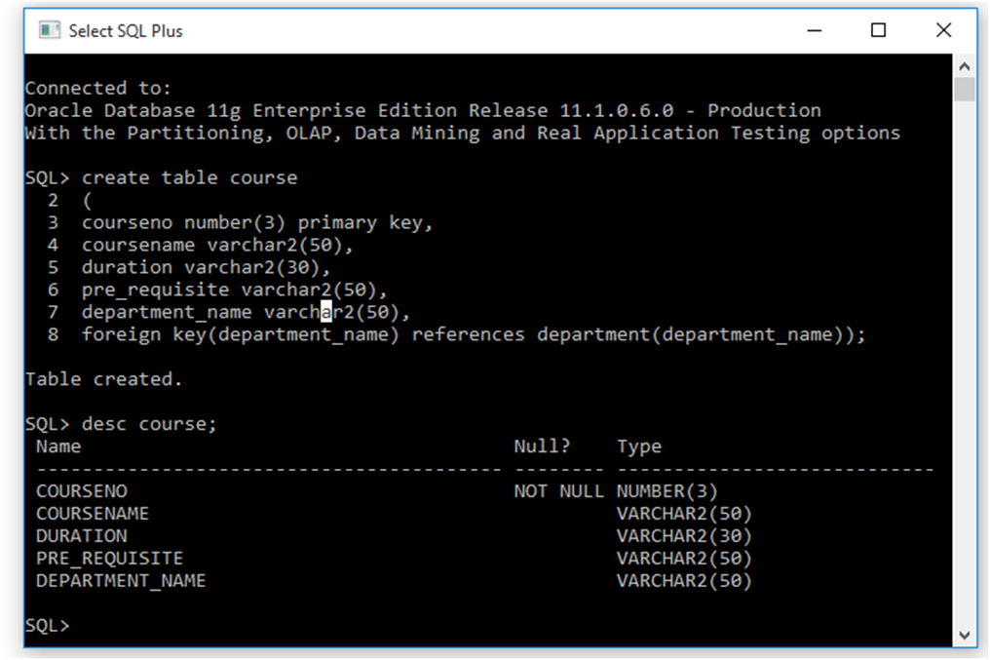

Table created

2. The ALTER TABLE Command: - This command is used to add, delete or modify columns in an existing table. You should also use the ALTER TABLE command to add and drop various constraints on an existing table.

a) Add new columns

    Syntax: ALTER TABLE<tablename> ADD (<new col><datatype(size),<new col>datatype(size));

**[SQL_3]** SQL> ALTER TABLE department ADD(dept_id NUMBER(2));

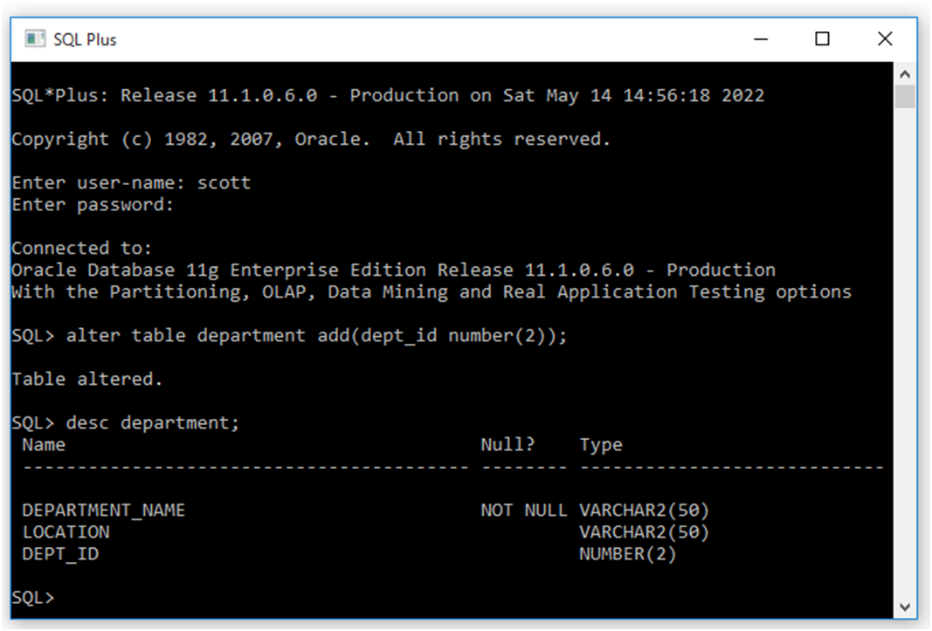

Table Altered

b)Modifying existing columns.

    Syntax:

     ALTER TABLE<tablename> MODIFY (<col><newdatatype>(<newsize>));

**[SQL_4]** SQL> ALTER TABLE department MODIFY (dept_id NUMBER(3));

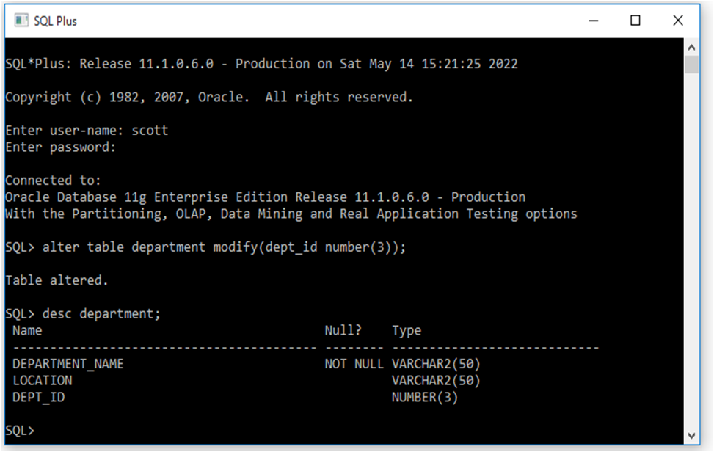

Table Altered

 c) Dropping a column from a table.

 Syntax:ALTER TABLE <tablename> DROP column <col>;

**[SQL_5]** SQL> ALTER TABLE course DROP COLUMN pre_requisite;

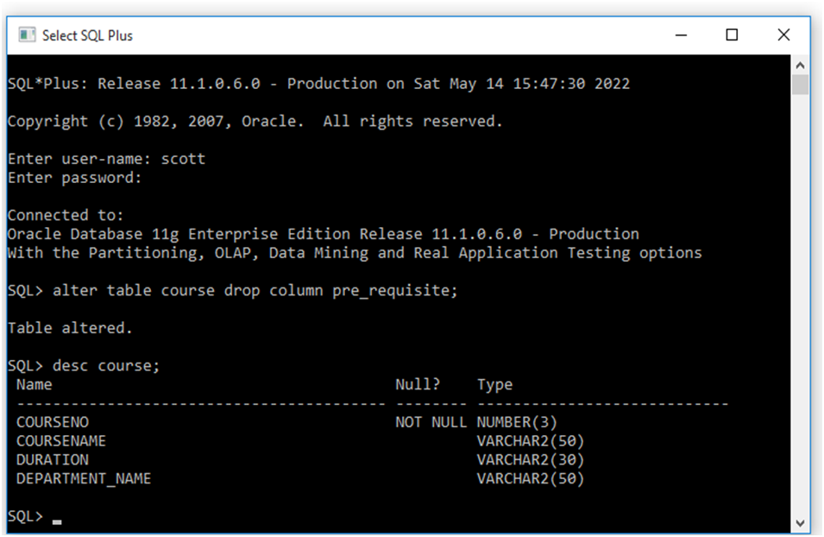

Table Altered

3. The TRUNCATE Command:- This command is used to remove all rows from the table, but the structure of the      table still exists.

    Syntax:

TRUNCATE TABLE <tablename>

   First insert records into the course table & then use truncate command.

Syntax: INSERT INTO<tablename> values(col1,col2,col3……..coln);

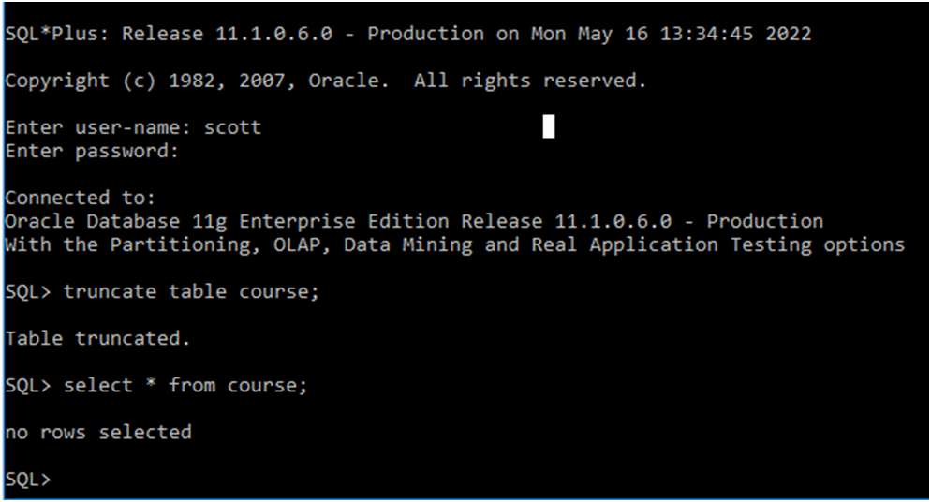

Table Truncated

1.The RENAME Command:- This rename command is used to change the name of an existing database object(like

table, Column) to a new name. Renaming a table does not make it to lose any data is contained within it.

Syntax: RENAME <oldtable> to <new table>

**[SQL_8]** SQL> RENAME courseto course1;

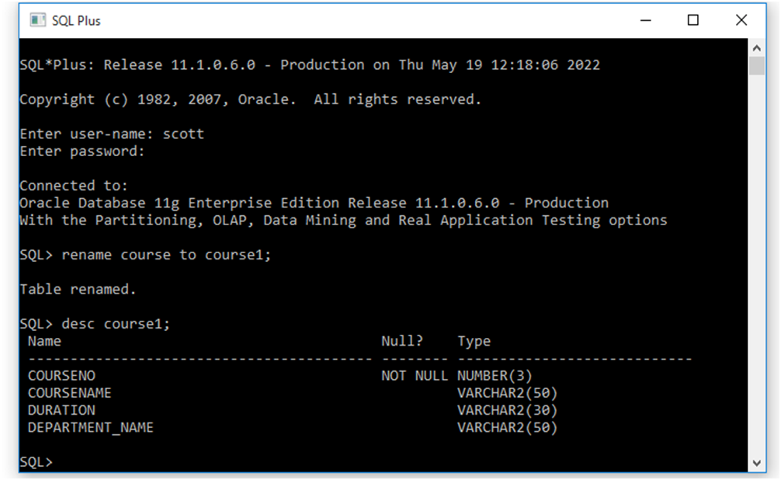

Table Renamed

2.The DROP command:- This command removes a table definition and all the data, indexes, triggers, constraints and permission specifications for that table.

          Syntax:

                DROP TABLE<tablename>;

**[SQL_8]** SQL> DROP TABLE course1;